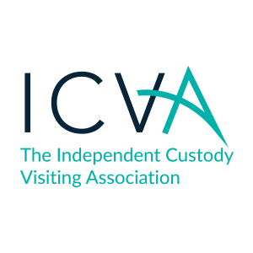
ICVA Decisions log – April 2022
Meeting took place on Microsoft Teams.

Date of Board Meeting | Topic of Paper | Recommendations | Decision Reached
28.04.22 | Chief Executive Update | Recommendations  - That the Board notes the report. | Decision:  - The board agreed that national work on ICOP should be paused for a period of 6-12 months.  - The board agreed that the messaging of ICOP and name should be revisited prior to further engagement.  - The board agreed that ICVA officers should continue to support those schemes who wish to undertake custody record reviewing as ad-hoc requests are received.
28.04.22 | Chair Recruitment | Options:  - The Board agree to pay an honorarium of circa £4,000 to the new Chair.  - The Board agree to pay an honorarium of circa £2,000 to the new Chair.  - The Board agree to not pay an honorarium to the Chair and proceed on a voluntary basis. | Decision:  - The board decided that both PCC and non-PCC applicants should be encouraged and allowed for the position of ICVA’s chair.  - The board agreed that ICVA’s incoming chair should receive an honorarium.  - The board delegated authority to finalise the honorarium payment to ICVA officers up to an annual value of c£400 per day, with a maximum annual budget of £4,000.
28.04.22 | Policy Review | Recommendations:  - Officers recommend that the officer and director expenses policy be subject to annual review.  - That the board otherwise agree the officer and director expenses policies.  - That the board agree the complaints policy for ICVA.  - That the board agree the information security policy.  - That the board agree the whistleblowing policy. | Decision:  - The board agreed to annual review the officer and director expenses policies.  - The board agreed the officer and director expenses policies.  - The board agreed the complaints policy for ICVA.  - The board agreed the information security policy.  - The board agreed the whistleblowing policy.
28.04.22 | ICVA Staff Handbook | Recommendations:  - That the board agree the staff handbook, including all new policies and the induction checklist.  - That the board agree the standard contract and self-assessment for new employees. | Decision:  - The board agreed the staff handbook, including all new policies and the induction checklist.  - The board agreed the standard contract and self-assessment for new employees.
03.05.22  (Decision attained via email) | NatWest Signatories | Recommendations:  - That the board agree to remove Katie Kempen and Craig Spencer as signatories to the NatWest accounts.  - That the board agree to add Erika Dallinger to the NatWest accounts. | Decision:  - The board agreed with 7 votes received by email that Katie Kempen and Craig Spencer be removed from the NatWest mandate.  - The board agreed with 6 votes received by email that Erika Dallinger be added as a signatory to the NatWest accounts.

