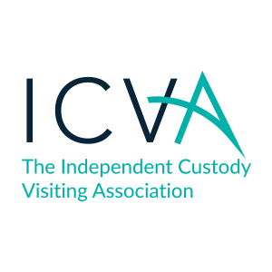
ICVA Decisions log - Extra ordinary decision – March 2020

Date of Board Meeting | Topic of Paper | Recommendations | Decision Reached (with vote detail where not unanimous)
12.03.2020 | Banking Resolutions | Recommendations  - The Board agree in line with the ICVA articles of association to make a decision via email.  - The Board pass the attached resolution to add Professor Nicholas Hardwick as a signatory to ICVA’s NatWest accounts.  - The Board pass the attached resolution to add Ms Sherry Ralph as a signatory to ICVA’s NatWest accounts. | Decisions:  - The Board agreed the three recommendations as laid out and had sight of the resolutions.

