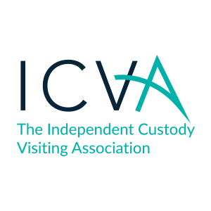
ICVA Register of Gifts and Hospitality 2018
Please note: Any reasonable working meals or refreshments at meetings are excluded from this register.
Date Received | Gift or Hospitality | Item Description | Circumstances of offer | Donor | Recipient | Accepted or Declined? | Reason | Register Entry made by? | Value
15/9/18 | Gift | Gift bag including chocolate, pens, handcream & lip balm | Given as a thank you for chairing the West Midlands ICV conference. | West Mercia OPCC | Chief Executive | Accepted | Accepted as thank you and to build relationships. | Chief Executive | c£10
10/10/18 | Hospitality | Event at Old Bailey with dinner and speaker | To promote independent custody visiting | City of London Police | Chief Executive | Declined | Unwell and unable to attend. | Chief Executive | Unknown
13/10/18 | Gift | Box of chocolates | Thank you for delivering ICV training | Cleveland OPCC | Chief Operating  Officer | Accepted | Accepted as a thank you | Chief Operating Officer | c£5
15/10/18 | Hospitality | Place at public lecture and meal following lecture | Invited to meet key stakeholders and discuss shared work. | The Howard League for Penal Reform | Chief Executive | Accepted | Accepted as an opportunity to promote independent custody visiting. | Chief Executive | c£30
15/10/18 | Hospitality | Place at public lecture | Invited to meet key stakeholders and discuss shared work. | The Howard League for Penal Reform | Chief Operating Officer | Accepted | Accepted as an opportunity to promote independent custody visiting. | Chief Executive | Under £5
16/1/19 | Hospitality | Canteen lunch | Canteen lunch provided as part of post meeting discussions. | The Police Federation | Chief Executive | Accepted | Accepted to continue discussions from meeting. | Chief Executive | Under £5

